**BSCS FINAL PROJECT PROPOSAL**

AR Treasure Hunt in UCP

*Term of Registration: Fall 2014*



Presented by:

|  |  |
| --- | --- |
| **Registration No:**  L1F13BSCS2161 | **Name:**  Muhammad Umar |
| L1S14BSCS2081 | Aiman Muzafar |
| L1S14BSCS2118 | H.M. Kazim Hafeez |
|  |  |

|  |
| --- |
| Faculty of Information Technology |

University of Central Punjab

**Project Title**

AR Treasure Hunt in UCP

**Project Advisor**

Prof. Kamran Shabbir

**Particulars of the students:**

|  |  |  |  |  |
| --- | --- | --- | --- | --- |
| **S.No** | **Registration#**  eg.**L1F00BSCS0101** | **Name in Full**  Use Block Letters | **CGPA** | **Signatures** |
| 1 | L1F13BSCS2161 | MUHAMMAD UMAR | 3.07 |  |
| 2 | L1S14BSCS2081 | AIMAN MUZAFAR | 3.29 |  |
| 3 | L1S14BSCS2118 | H.M.KAZIM HAFEEZ | 3.70 |  |

**Advisor’s Consent**

I Prof./Dr./Mr./Ms. ________________________________________________ am willing to guide these students in all phases of above-mentioned project as advisor. I have carefully seen the Title and description of the project and believe that it is of an appropriate difficulty level for the number of students named above.

|  |  |  |
| --- | --- | --- |
| **Note:**  Advisor can’t be changed without prior permission of the Manager Projects and the duration for completion of the Project is 2 regular semesters (approx.) from the date of Registration of Research Project. | Signatures and Date  |  | | --- | |  |   **Advisor** |

**EVALUATOR/REFEREE 1**

|  |  |  |  |  |  |
| --- | --- | --- | --- | --- | --- |
| I have carefully read the project proposal and feel that the proposed project is a useful one and of a sufficient difficulty level to justify 2 regular semesters workload for above mentioned students. I have made recommendations in the evaluation form to improve the scope and quality of the project. | | | | | |
|  | | | | Signatures and Date | |
|  |  |  |  |  |  |
|  | | | |  |

**EVALUATOR/REFEREE 2**

|  |  |  |  |  |  |
| --- | --- | --- | --- | --- | --- |
| I have carefully read the project proposal and feel that the proposed project is a useful one and of a sufficient difficulty level to justify 2 regular semesters workload for above mentioned students. I have made recommendations in the evaluation form to improve the scope and quality of the project. | | | | | |
|  | | | | Signatures and Date | |
|  |  |  |  |  |  |
|  |  |  |  |  |
|  | | | |  |

**Abstract**

AR Treasure Hunt in UCP is an Augment Reality Based game in which two or more teams will compete against each other to find a hidden treasure with in the campus. The game will use Vuforia Library for Unity 3D to implement the game.

**Introduction and Background**

AR Treasure Hunt in UCP is an Augment Reality Based game in which two or more teams will compete against each other to find a hidden treasure with in the campus. The teams will start with a poetic clue which will lead them to a place after solving it. On the place there will be another clue hidden somewhere. The Player will have to look around with their smart phones to find the clue. Once a clue has been found it will present them with another poetic clue and this process will be repeated until a final clue is delivered or a team has found the treasure already.

**Statement of the Problem**

According to the research conducted there is no well-known implementation of the game “Treasure Hunt” in augmented reality. After the successful implementation of this project we will have a mobile AR game for the treasure hunt.

**Objective(s) / Aim(s) / Target(s)**

The objective of this project is to implement classical Treasure Hunt in Augmented Reality technology and make it mobile multiplayer game. Teams shall be competing in real environment against each other.

**Completeness Criteria**

Our complete project will be an AR Based Mobile application which will be capable of letting user experience treasure hunt in UCP campus.

**Challenges**

* Understanding the concepts of Augmented Reality Technology
* Learning and understanding Unity 3D game engine
* Learning and understanding Vuforia
* Learning and understanding GPS API
* Creating a story line

**Knowledge Areas Required**

Database Concepts

Programming Fundamentals

Object Orientated Programming

Data Structures and Algorithms

Introduction of Software Engineering

**Learning Outcomes**

* Becoming familiar with Unity 3D game engine
* Becoming familiar with Vuforia
* Becoming familiar with GPS API in Unity 3D
* Becoming familiar with relevant libraries in Unity 3D game engine

**Nature of the End Product / Research Outcomes**

The end program will be a mobile game application which will let users play treasure hunt in Augmented Reality experience.

**Related Work / Literature Survey / Literature Review**

According to our knowledge there is no good application in Augmented Reality for this game has been made yet. The only application closest to ours, we found, was “An augmented reality game for Zurich citizens and visitors”. But game is only playable in Zurich City.

**Deliverables / Work Breakdown Structure**

|  |  |  |  |  |
| --- | --- | --- | --- | --- |
| **Phase 1: Research** | **Phase 2: Design** | **Phase 3: Modeling** | **Phase 4: Implementation** | **Phase 5: Testing** |
| **Step 1.1**  **Game overview** | **Step 2.1**  **Decomposition** | **Step 3.1**  **Relationships** | **Step 4.1**  **Coding** | Activity4.1: Unit testing |
| Activity1.1.1: identify Game concept | Activity2.1.1: identify Functions and entities  (Functional decomposition) | Activity3.1.1: Design use case diagram |  | Activity4.2: Integration testing |
| Activity 1.1.2: identify  Interface | Activity2.1.2: identify Features of game  (Feature oriented) | Activity3.1.2: Design class diagram |  | Activity4.3: Test all use cases |
| Activity 1.1.3: identify characters | Activity2.1.3: identify attributes and methods of entities  (Object oriented) | Activity3.1.3: Design  ER diagram |  | Activity4.4: System testing |
| **Step 1.2:**  **Gameplay and Mechanics** | **Step 2.2:**  **Architectural style** | Activity3.1.4:  Attributes and types of Database |  |  |
| Activity 1.2.1: identify play flow and mechanics | Activity2.2.1: identify architectural design |  |  |  |
| Activity 1.2.2: identify game levels and sound | **Step 2.3:**  **Interface** |  |  |  |
| Activity 1.2.3:identify design and implementation | Activity2.3.1: design main screen |  |  |  |
|  | Activity2.3.2: design menu options |  |  |  |
| **Step 1.3:**  Gather Functional Requirement | Activity2.3.3: design login screen |  |  |  |
|  | Activity2.3.5: design multiplayer screen |  |  |  |
|  | Activity2.3.6: design scorecard screen |  |  |  |
| **Step 1.4:**  **Non Functional Requirement** |  |  |  |  |
| Activity 1.4.1: identify Performance requirement |  |  |  |  |
| Activity 1.4.2: identify Safety requirement |  |  |  |  |
| Activity 1.4.3: identify security requirement |  |  |  |  |
| Activity 1.4.4: identify Quality requirement |  |  |  |  |

**Project Plan / Project Schedule / Project Timetable / Project Calendar**

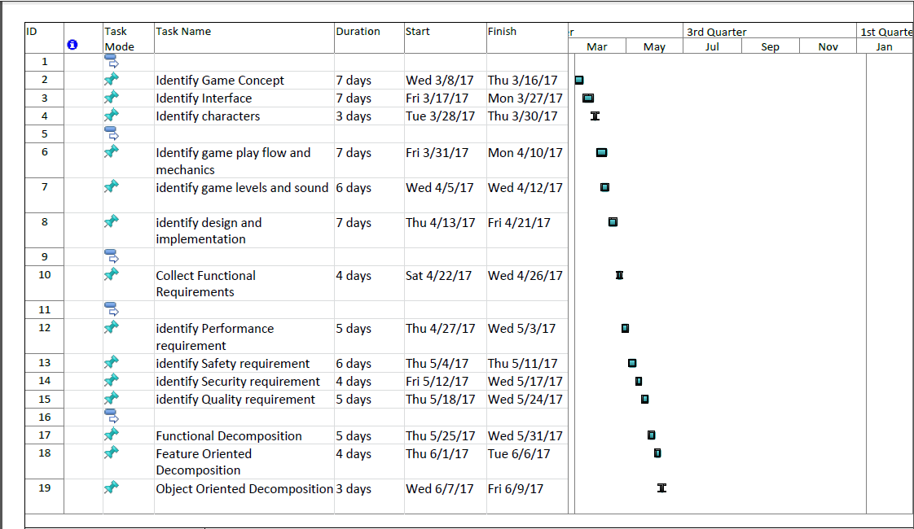

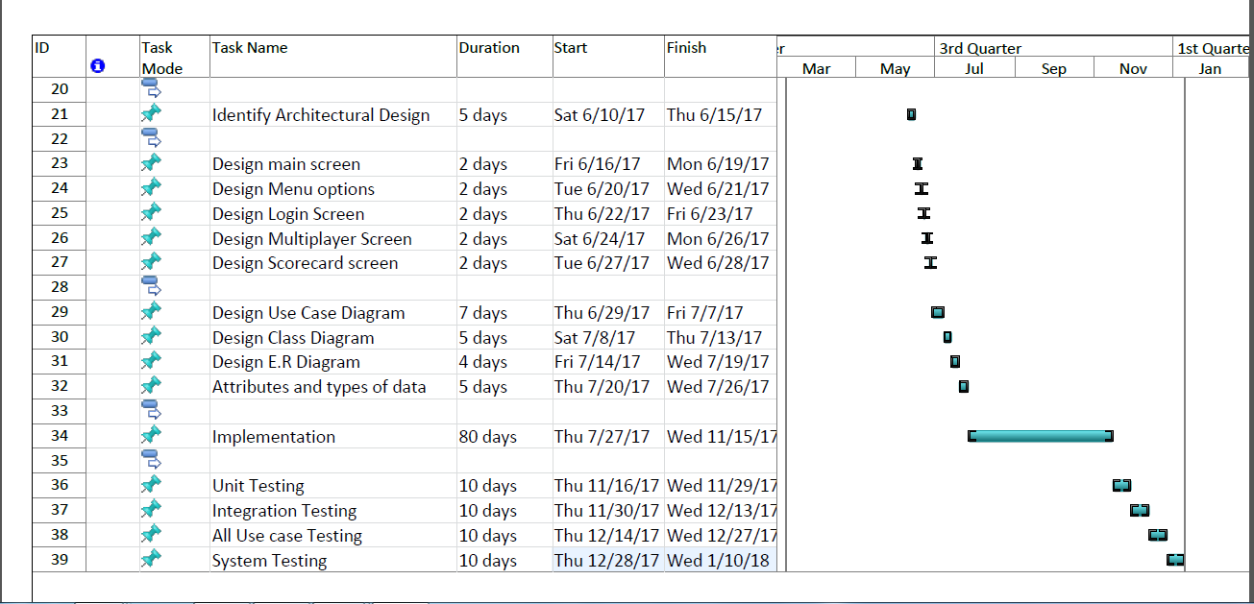

**Resources Required**

|  |  |
| --- | --- |
| **Resources** | **Availability in UCP** |
| A reserved computer in Cl-205 Lab | Available |
|  |  |
|  |  |

**Miscellaneous**

<none>.

**Abstract Story Board and Identification of Characters (For Game-Oriented Projects Only)**

The game doesn’t involve any characters and it is a real time based game which will use Augmented Reality technology to implement. The players will get a starting clue which, after solving, will lead them to a place located in UCP. The players will then have to find another clue hidden at that place and that clue will lead them to another place after it has been successfully solved. The team to reach the place of hidden treasure first will win the game.

The story line and clues are yet to be made and they will be improved throughout the development of this project.

**Sketch of Proposed Solution (For Research-based and Hardware-Oriented Projects Only)**

<none>.

**References/Bibliography**

<none>.